Match the following terms to the correct example:
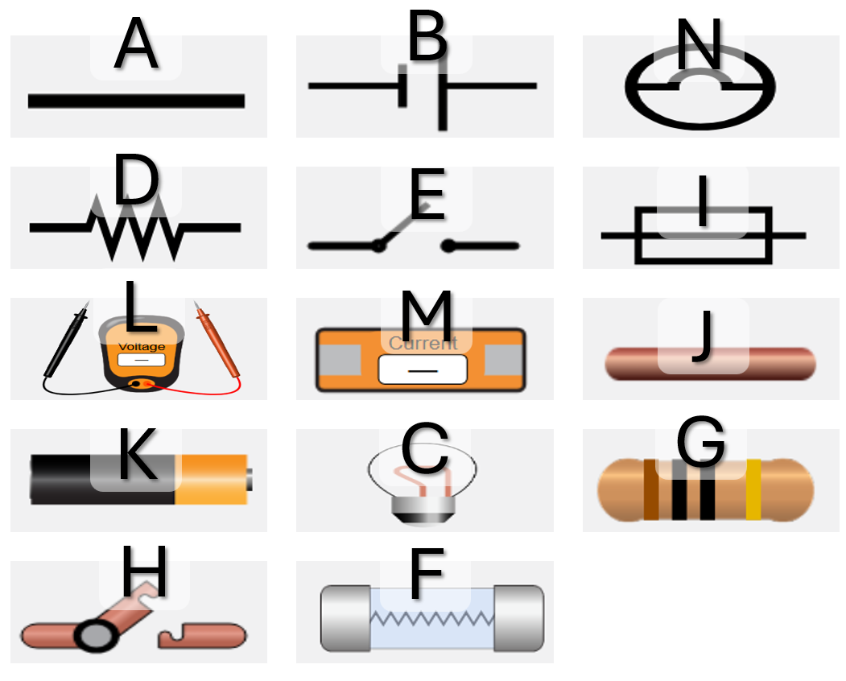
Word Bank: Ammeter, Voltmeter, Fuse, Light Bulb, Cell, Switch, Wire, Resistor
1. A _________________________
2. B _________________________
3. C _________________________
4. D _________________________
5. E _________________________
6. F _________________________
7. G _________________________
8. H _________________________
9. I _________________________
10. J _________________________
11. K _________________________
12. L _________________________
13. M _________________________
14. N _________________________

